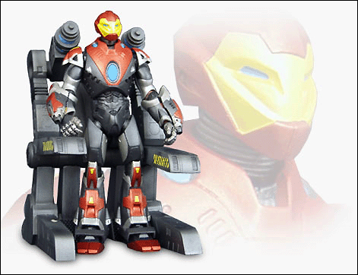
Super Hero Stuff.Com
Ultimate Iron Man Action Figure
$17.99 - Comes with the armor carriage and wiring. Read below for specifics.
Another amazing action figure put out by Marvel. The armor is amazing, the gauntlets come off and everything. Tony Stark is Iron Man. With his Irontech armor, a revolutionary mixture of biochemical engineering and robotics, Tony Stark has figured out a way to save his own life from a degenerative brain tumor while at the same time giving him amazing powers. Even though the world knows Tony Stark is Iron Man, No one knows how he does it - - for Tony Stark will never sell his amazing Irontech invention for fear that it will be used as a weapon of mass destruction. That is the price and the responsibility of being the red and golden knight of a modern time.

